

**Employer Registration Form** Limited

Name of the company:*



Company’s registration numer:*



Company’s registration Address:



Company's business address(If different to registration Address)



Telephone Number:



E-mail Address:



Business description:

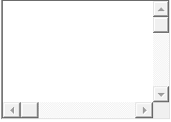

Date of the first payment*:



Number of employees*:

Will the company employ subcontractors in the construction sector? *

Yes

No

First Director’s Forename and Surname:



First Director’s NIN:



Second Director’s Forename and Surname:



Second Director’s NIN:



Additional Information:

